English 10 A Syllabus
Trimester 1 2015-2016
Mr. Kind

Hello and welcome to English 10A. Over the course of this semester we will cover content ranging from colonial non-fiction to Native American folklore; we will even have time to get some horror stories in around Halloween! You will be able to keep up with what we are working on each week my following my teacher website on the schools main page. I will update the site weekly with pertinent information. Overall, I run a nice relaxed class. As long as everyone is contributing and participating we will have a very fun class. I do not like to give a lot of busy work. However, if I feel that people are not pulling their weight in discussions I will be forced to start checking to see that you have a thorough grasp of the material. This will make no one happy.

Grading
Your final grade will be compiled as a culmination of your daily participation and attitude, class/homework, and projects/tests. Having a good attitude and actively participating in discussions is a great way to help your grade. Every day I will mark your participation as active, passive, or no response. YOU CANNOT MAKE UP PARTICIPATION POINTS.

30% Daily professionalism
30% Classwork and Homework
40% Tests and Projects

There will be some opportunity for extra credit throughout the trimester in different forms.

Tardy Policy
If you are not in the room and ready to work when the bell rings, you are late. Three late marks earns you a referral and an hour of afterschool detention. If it continues to be an issue after that, I will have to contact your parents and see if we can get you extra alarm clocks in the morning.

What to do when you are absent
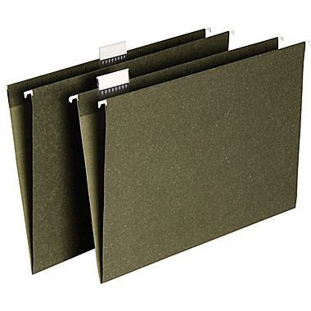
If you are absent, it is your responsibility to get the work you missed and to turn in anything that was due the day you come back. That means if you miss school on the day a project or test is scheduled, it is due the day you come back. If you missed multiple days we will work something out. The only grade you cannot make up, is the participation for that day. So make sure your absences are few and far between.
All absent assignments will be in the file folder near my desk.

Late work
I do take late work! However, every day it is late I take 10% off the final grade. If you get it to me before the end of the school day (the first day it is due) it is only 5% off.

One last thing
This is the big one. This classroom is going to be one where we share. We are going to be sharing ideas, opinions, different interpretations of text, everything. Because of that, the number one rule in this class is that you will respect each other’s views. You do not have to agree with each other 100% of the time (frankly it would be boring if you did). We will be discussing some heavy topics during this trimester. There is no quicker way to get detention in my class then to be disrespectful to another student sharing their views. That means do not interrupt, do not make personal attacks, do not take things personally. Do engage in thoughtful discussion. Do have an open mind. You do not need to change your views, just be open to hearing the other side and accepting of theirs. Adhering to these general guidelines will make our trimester easy and relatively painless.

By signing I acknowledge and agree to follow these procedures of behavior in the classroom.

_________________________ ___________
(Signature) (Date)

