Intro to Theatre Syllabus
Mr. Kind

Hello and welcome to Intro to Theatre. This class will look at the elements of theatre: acting, technical, as well as history. This class will be much more technically driven than Intro to Acting. We will try to give equal time to all important aspects of theatre, but 12 weeks is not a lot of time. During that time we will study the following:

Greek and Roman Theatre
Early Asian Theatre
Medieval Theatre
Theatre of the English and Italian Renaissance
Parts of a Theater
Set Design and drafting
Lighting Theory
Using sound in theatre
Reading of Dramatic Literature
Scene production

Grading
33% Daily participation
33% Performances
33% Journals and Projects

Classroom Rules
- Be respectful
- Do not climb on platforms
- Do not touch the curtains unless directed to do so by me
- When you are given time to work on projects, you are expected to work. This is not social hour.
- Unless we are working on something that requires you to be in the shop, the shop is off limits. You are allowed to use the restroom in the backstage area however.
- Sound/Lighting equipment
  - Do not touch any equipment unless you are directed to do so. That goes for the sound and lighting board as well.
- Show up ready to work.

Tardy Policy
If you are not in the room and ready to work when the bell rings, you are late. Three late marks earns you a referral and an hour of after-school detention. If it continues to be an issue after that, I will have to contact your parents.
I do understand that the theatre is further away than all of your other classes so I will be a little lenient on this. 30 seconds or so late I can deal with. Any more than that is a tardy.

What to do when you are absent
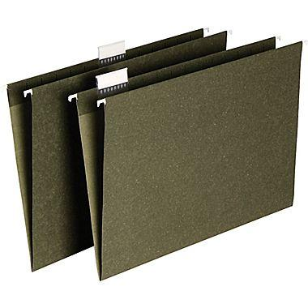
If you are absent, it is your responsibility to get the work you missed and to turn in anything that was due the day you come back. That means if you miss school on the day a project or performance is scheduled, it is due the day you come back. If you missed multiple days we will work something out. The only grade you cannot make up, is the participation for that day. So make sure your absences are few and far between. This is a performance class, you have to be here to perform.

Late work
I do take late work! However, every day it is late I take 25% off the final grade. If you get it to me before the end of the school day (the first day it is due) it is only 10% off.
Performances are less forgiving. You perform on the day you are scheduled to. If there are extenuating circumstances (death in the family, lost your voice) we can work something out.

One last thing
This is the big one. This classroom is going to be one where we share. We are going to be sharing ideas, opinions, different interpretations of text, everything. Because of that, the number one rule in this class is that you will respect each other’s views. You do not have to agree with each other 100% of the time (frankly it would be boring if you did). There is no quicker way to get detention in my class then to be disrespectful to another student sharing their views. That means do not interrupt, do not disrupt other performances, do not take constructive criticism personally. Do engage in thoughtful discussion. Do have an open mind. You do not need to change your views, just be open to hearing the other side and accepting of theirs. Adhering to these general guidelines will make our trimester easy and relatively painless.

By signing I acknowledge and agree to follow these procedures of behavior in the classroom.

_________________________ ___________
(Signature) (Date)

_________________________ ___________
(Parent Signature) (Date)

