SAT
PREPARATION COURSE
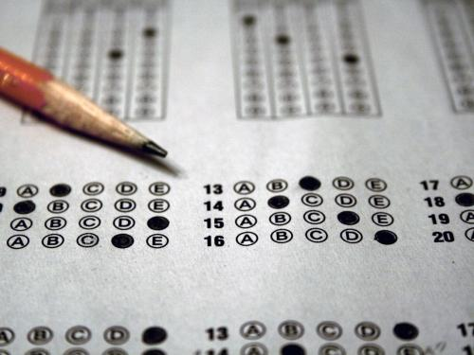
Mr. Kind jkind@gulllakecs.org
ROOM 1405 Trimester II 2016-17 (269) 548-3494

COURSE DESCRIPTION
The purpose of this course is to prepare students for the SAT Examination by providing them with the necessary skills, test-taking strategies, and resources needed to be successful on the exam. In doing so, students will gain a better understanding of the rules and guidelines of standard written English and the purpose and function of rhetorical and linguistic strategies in both fiction and nonfiction writing.

This course is designed to make students aware of and comfortable with the features and format of a college entrance exam. Throughout the duration of the trimester, students will be on a five-and-a half week rotation between English Language Arts (ELA) and Mathematics.

The rotation schedule is as follows:
Teacher | Subject | Room | Students/ Rotation
Mr. Jonathan Kind  (269) 548-3582  jkind@gulllakecs.org | Reading/Writing and Language | 1405 | 1st Block: Kind to Flynn  2nd Block: Kind to Flynn
Mrs. Andrea Walker  (269) 548-3497  awalker@gulllakecs.org | Reading/Writing and Language | 2406 | 4th Block: Walker to Jaros
Mrs. Trisha Stevens  (269) 548-3546  tstevens@gulllakecs.org | Reading/Writing and Language | 1409 | 5th Block: Stevens to Kiser
Mrs. Anne Flynn  (269) 548-3479  aflynn@gulllakecs.org | Mathematics | 1207 | 1st Block: Flynn to Kind  2nd Block: Flynn to Kind
Mrs. Michelle Jaros  (269)548-3353  mjaros@gulllakecs.org | Mathematics | 2213 | 4th Block: Jaros to Walker
Mrs. Brittany Kiser  (269) 548-3492  bkiser@gulllakecs.org | Mathematics | 2302 | 5th Block: Kiser to Stevens
In each subject area students will do the following:
- Develop and practice test taking strategies and time management skills.
- Become oriented to and familiarized with the SAT Exam format, expectations, and procedures.
- Take diagnostic, formative, and summative assessments which prepare students for the SAT Exam.
- Take and score SAT practice tests.

COURSE GOALS
Primary Goal
For ALL students to receive not only a passing score in each area of the SAT, but to gain the confidence and skills needed to exceed their performance goal.
Secondary Goals
- For students to identify their strengths and weaknesses through the the use of diagnostic, formative, and summative assessments and to develop strategies for improvement.
- To expose students to differentiated lesson plans which target a wide range of abilities.
- To collaborate with peers in both large and small group settings on course-related topics.
- For students to acquire strategies to cope with and overcome test-related anxiety and stress.
- For students to find relevancy, purpose, and application in the course material.

COURSE MATERIALS
- Pens/Pencils/Highlighters
- IPads
- Notebook Paper/Spiral Bound Notebook
- Earbuds/Headphones to listen to guided online instructions

CLASS EXPECTATIONS
- Be on time, everyday. Per school policy, when a student reaches 3 tardies, he or she will be issued a tardy referral.
- Be in your seat, ready to start class, when the bell rings.
- NO CELL PHONES AT ANYTIME! This rule is particularly important for this class because during the actual SAT test, if a cell-phone is seen or heard, all of the tests will be voided.
- Be respectful to your teacher and classmates at all times.
- Be on time, on task, and on topic at ALL TIMES.
- Maintain a positive attitude, and be open to new ideas and concepts.
- Check Mr.Kind’s teacher page daily for agendas, due dates, reminders, and announcements.
- Be responsible for contacting Mr. Kind to make up work when absent.

GRADING
This class does not receive a letter grade. The class is on a credit no credit basis. Each day, the student will receive points for assigned material and/or participation with the use and improvement through Khan Academy. At the end of the trimester, the respective teachers will tally the points. To receive credit that student must have a 70% as well as show improvement in each area we cover on the SAT.

PRODUCTIVITY POINTS (10 POINTS PER DAY) ARE BASED ON:
- FOCUSED, on-task on work at all times
- NO CELL PHONE USE (CELL PHONES CANNOT BE VISIBLE)
  - 1st time points taken away for the day
  - 2nd for the week (you may get them back if you put your phone in the Phone-Jail for 5 consecutive school days)
  - 3rd Parent Phone call
- PARTICIPATION IN ACTIVITIES, DISCUSSIONS, AND IN CLASS WORK
- APPROPRIATE, PROFESSIONAL BEHAVIOR

Detach, and return the signed portion of this syllabus to Mr. Kind for your first 10 points in Synergy.
---------------------------------------------------------------------------------------------------------------------------------------

PARENT/GUARDIAN ACKNOWLEDGEMENT FORM

Each student is required to have a parent/guardian read the above course syllabus and acknowledge understanding by signing below. Students must return this signed portion no later than Friday, December 9, 2016.

I have read the course syllabus and understand the major components and requirements for this course. I understand that if I have any questions or concerns at any time, I can contact my student’s teacher via email or phone.

_______________________________________ ____________________________________
Student Name (Please print.) Student Signature

_______________________________________ ____________________________________
Parent/Guardian Name (Please print.) Parent/Guardian Signature

